PROJECT REPORT OF INDUSTRY ORIENTED HANDS ON EXPERIENCE (IOHE) ON
OPM Connects
Submitted in partial fulfilment of the requirements for the award of degree of

BACHELOR OF ENGINEERING
In
COMPUTER SCIENCE AND ENGINEERING

Submitted by: Supervised By
Ayush Kumar (2211981121) Dr. Monika Aggarwal
Aditya Raj (2211981027) (Mentor)
Anubhav Jasrotia (2211981081) Associate Professor
Aman Sharma (2211981047) Chitkara University



DEPARTMENT OF COMPUTER SCIENCE AND ENGINEERING CHITKARA UNIVERSITY INSTITUTE OF ENGINEERING AND TECHNOLOGY CHITKARA UNIVERSITY, PUNJAB, INDIA

S.No. Title Page No.
- Acknowledgement 4
- List of Figures and Tables 9 - 11
- Abstract 5
- Introduction 1
- Methodology 6
- Tools and Technologies 7 - 11
- Implementation 12 - 13
- Major 14 - 19
Findings/Outcomes/Output/Results
- Conclusion and Future Scope 19 - 20
- Bibliography and References 21

CONTENTS DECLARATION

I hereby certify that the work which is being presented in the project report entitled
OPM Connects in partial fulfilment of requirement for the award of the degree of Bachelor of Engineering (Computer Science and Engineering) submitted in the department of Computer Science and Engineering at Chitkara University Institute of Engineering and Technology, Chitkara University, Punjab, India, is an authentic record of my own work carried out under the supervision of Dr. Monika Aggarwal. The matter presented in this project report has not been submitted in any other university/institute for the award of any degree.
Place: Rajpura

Date: 09/05/2026 Ayush Kumar (2211981121)
Aditya Raj(2211981027)
Anubhav Jasrotia(2211981081)
Aman Sharma(2211981047)

This is to certify that the above statement made by the candidate is correct to the best of my knowledge and belief.

Dr.Monika Aggarwal
Associate Professor
Department of Computer Science and Engineering

ACKNOWLEDGEMENT

We would like to express our profound gratitude and sincere appreciation to everyone who has supported and guided us throughout the development of our project, “OPM Connects:Smart Doctor Appointment Booking and Consultation Platform.”
First and foremost, we are deeply indebted to our project guide, [Dr. Monika Aggarwal Mentor , Associate Professor], for their continuous support, patience, and invaluable mentorship. Their technical insights and constructive feedback were instrumental in shaping this project and bringing it to completion.
We also wish to extend our sincere thanks to [B.E CSE 4th year , Dr, Shyam Goyal Head of the Computer Science Department, and our esteemed institution Chitkara University, for providing us with the necessary resources, infrastructure, and a conducive environment to carry out this research and development work. Furthermore, we would like to acknowledge the collaborative spirit of our project team:Ayush Kumar,Aditya Raj, Anubhav Jasrotia and Aman Sharma. The successful completion of OPM Connects is the result of our collective hard work, dedication, and mutual support.
Last but not least, we are forever grateful to our parents, family, and friends for their unwavering moral support, encouragement, and understanding during the course of this project.

Project Team:
- Ayush Kumar (2211981121)

- Aditya Raj (2211981027)

- Anubhav Jasrotia (2211981081)
• Aman Sharma (2211981047)

ABSTRACT

1.1 Problem Background
In today’s fast-paced world, booking a doctor appointment often involves long waiting times, manual phone calls, physical hospital visits, and lack of real-time availability information. Patients frequently face difficulties in finding suitable doctors, checking available time slots, comparing consultation fees, and managing appointments efficiently.
Hospitals and clinics also struggle with appointment scheduling conflicts, patient record management, and communication gaps. Traditional booking systems are mostly manual or partially digital, leading to inefficiencies, double bookings, and poor patient experience.
With increasing digital transformation in healthcare, there is a strong need for a centralized, user-friendly, and secure platform that allows patients to seamlessly book doctor consultations within seconds.

1.2 Objective of the Project
The objective of OPM Connects is to develop a centralized web-based doctor appointment booking system that connects patients, doctors, and administrators on a single digital platform.
The system aims to:
- Simplify appointment booking process
- Provide real-time doctor availability
- Enable secure and fast online booking
- Improve communication between patients and healthcare providers
- Reduce manual scheduling errors

1.3 Proposed Solution / System Overview
The proposed system is a full-stack web-based healthcare platform that allows patients to:
- Search doctors by specialization
- View doctor profiles and availability
- Book appointments instantly
- Manage bookings (reschedule/cancel)
- Receive appointment confirmation The system provides role-based
access:
Patient Panel:
- Register/Login
- Search doctors by specialization, location
- Book consultation
- View booking history Doctor Panel:
- Manage availability
- View upcoming appointments
- Update profile and consultation fees Admin Panel:
- Manage doctors and patients
- Monitor bookings
- View system analytics
- Handle user queries
The platform ensures secure authentication and smooth appointment scheduling through structured APIs and database integration.

1.4 Key Features or Functionality
- Doctor search with filters (specialization, experience, availability)
- Real-time appointment booking
- Secure login and registration
- Role-based dashboards (Patient, Doctor, Admin)
- Appointment confirmation system
- Booking history management
- Admin analytics dashboard
- Responsive user interface

1.4 Technology / Method Used
The system is developed using modern web technologies:
- Frontend: React.js
- Backend: Node.js with Express.js
- Database: MongoDB
- Authentication: JWT (JSON Web Token)
- Architecture: Full-Stack Web Application
- Deployment: Cloud-based hosting
The system follows REST API architecture to ensure scalability and efficient communication between frontend and backend.

.1.6 Expected Outcome & Benefits
The proposed system is expected to modernize the healthcare appointment booking process by providing a centralized and efficient digital platform.
Benefits for Patients:
- Quick booking within seconds
- Reduced waiting time
- Easy access to doctor information
- Convenient appointment management Benefits for Doctors:
- Organized schedule management
- Reduced manual appointment handling
- Better patient communication Benefits for Administration:
- Centralized data management
- Improved operational efficiency
- Better tracking and reporting
Overall, OPM Connects will improve healthcare accessibility, reduce administrative workload, and enhance user satisfaction.

1.7 Original Contribution Statement
The originality of this project lies in developing a seamless, fast, and user-friendly healthcare booking platform tailored for instant consultation scheduling.
Future enhancements may include:
- AI-based doctor recommendation system
- Video consultation integration
- Online payment gateway
- Prescription upload/download feature
- Mobile application support
- Automated reminder notifications
These enhancements will further improve patient convenience and healthcare service efficiency.

1.8 Implementation
The implementation of “OPM Connects: Online Doctor Appointment & Medicine Platform” was carried out using modern web development technologies to create a user-friendly and efficient healthcare management system. The frontend of the platform was developed to provide an easy interface for patients and doctors, while the backend handled data processing, appointment management, and medicine-related operations.
The system allows users to:
- Register and log in securely
- Book doctor appointments online
- View doctor availability and schedules
- Manage patient details and appointment records
- Access medicine-related services and information
- Receive notifications and confirmations for appointments
The platform integrates database management for storing patient, doctor, and appointment information securely. APIs and backend services were used to enable smooth communication between frontend and backend components.

1.9 Result
The developed system successfully simplified the process of booking doctor appointments and managing healthcare services online. Users were able to interact with the platform easily and perform appointment-related tasks without visiting hospitals physically.
The platform achieved:
- Faster appointment scheduling
- Reduced manual paperwork
- Improved accessibility to healthcare services
- Better management of patient and doctor records
- User-friendly interaction and responsive design
The project demonstrated how technology can improve healthcare services by making them more organized, accessible, and efficient.

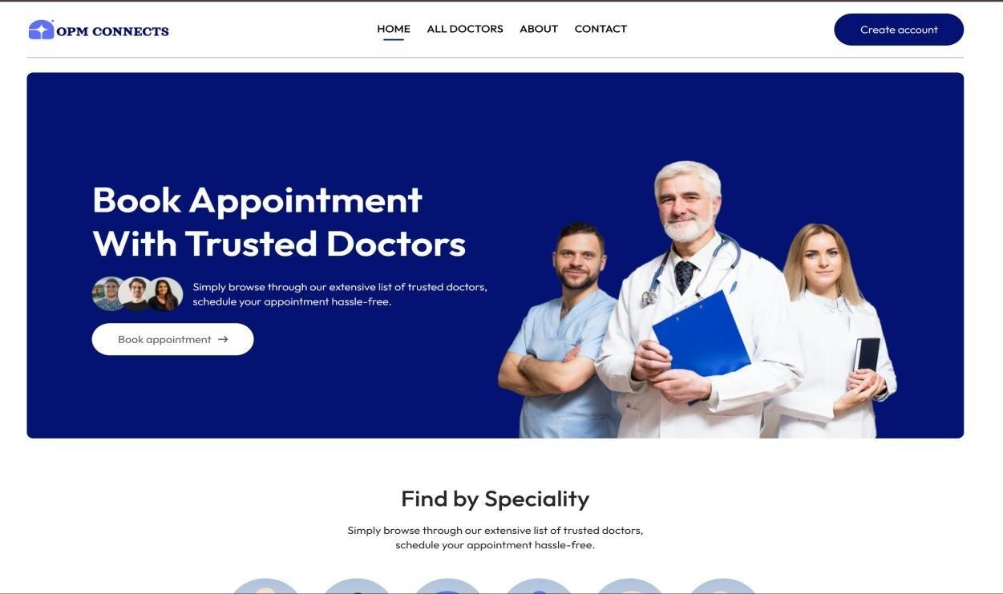
Outcomes

:
-

Landing

page

Login / Signup page
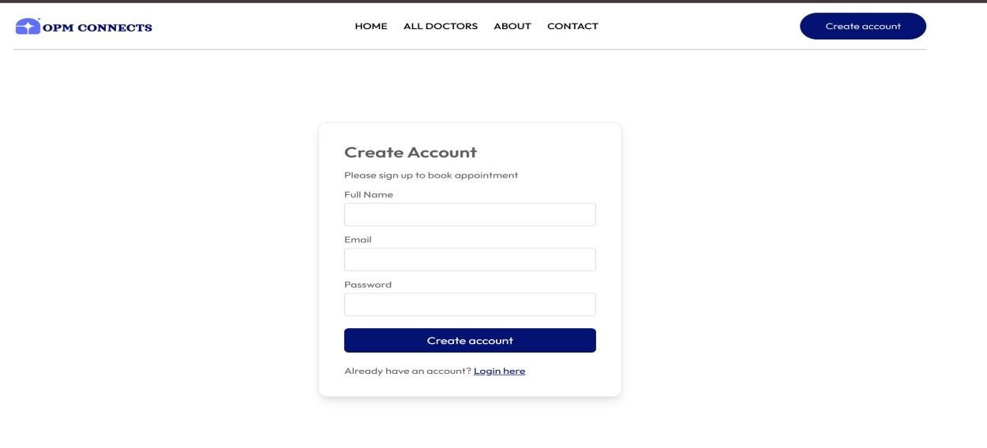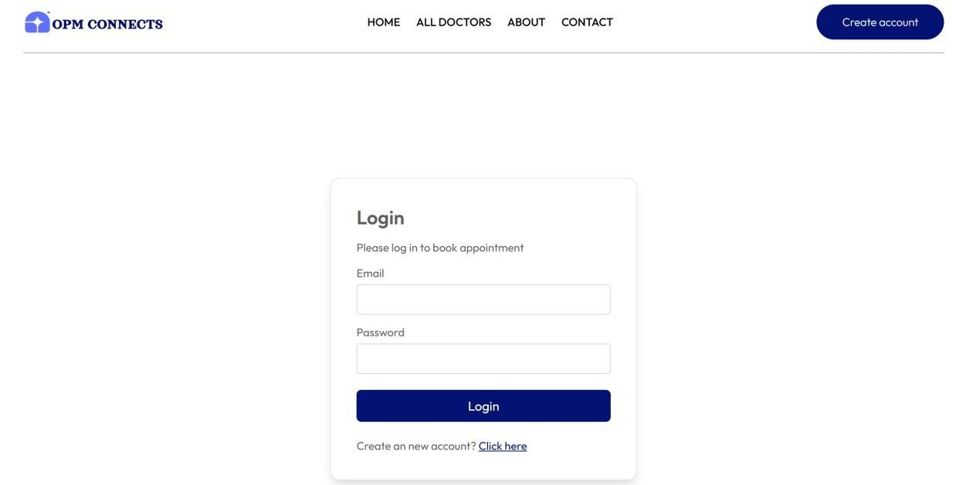

Speciality
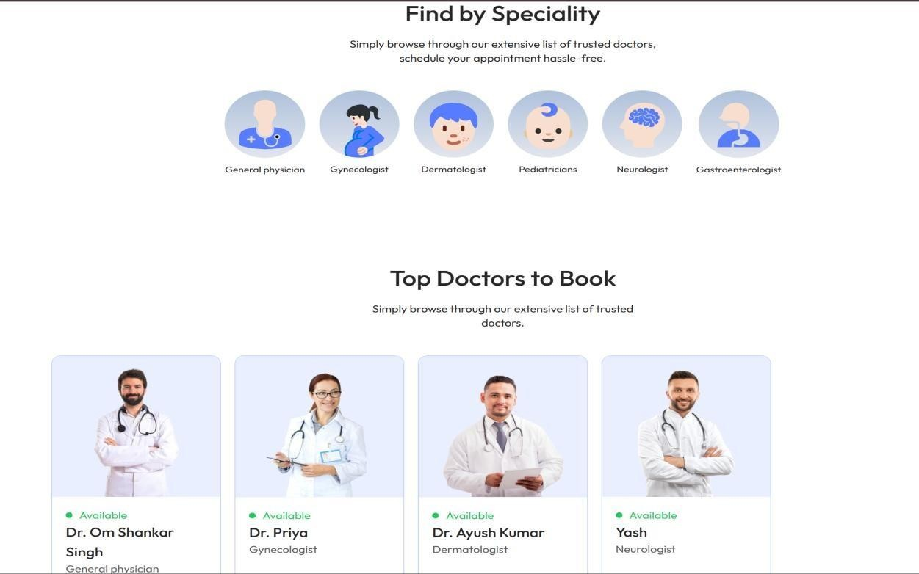

Book Doctor Appointment
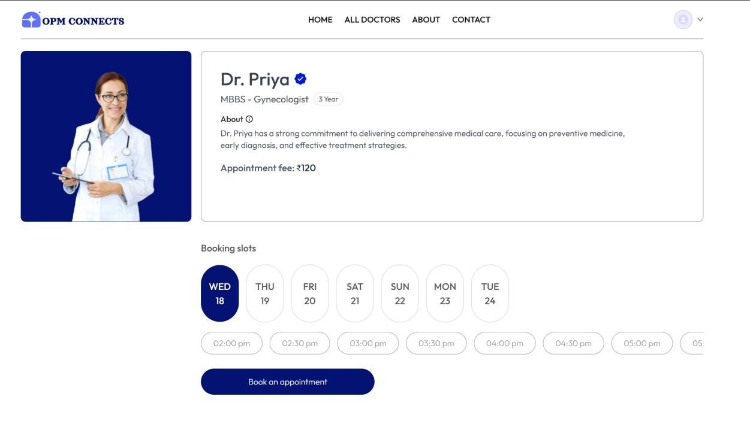

Check Appointments
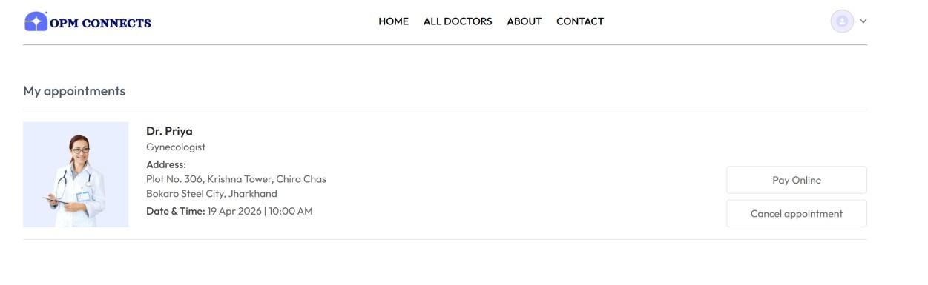

Abou
t Us

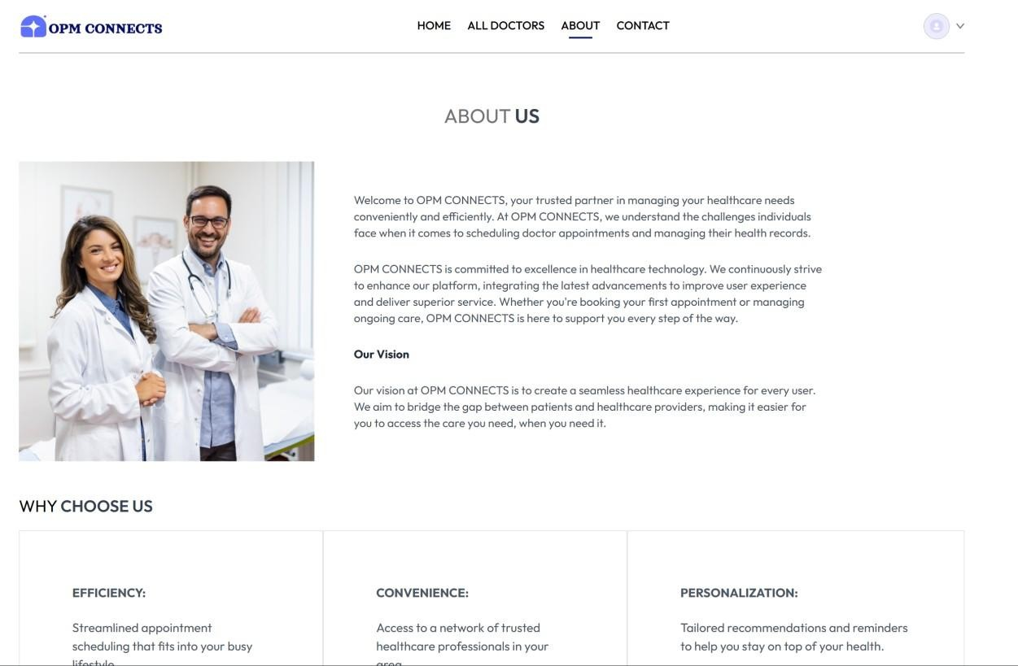

Contact Us
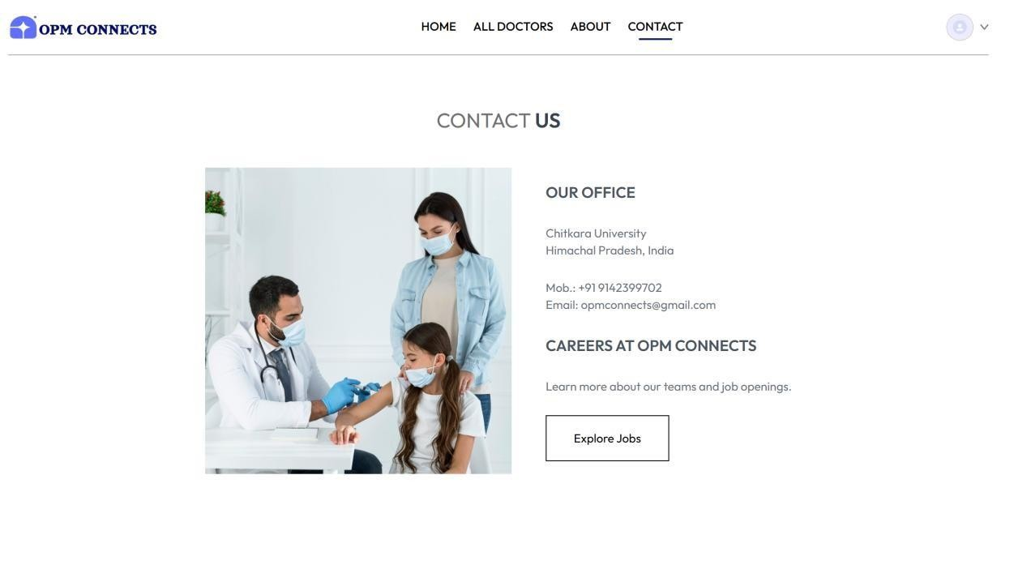

2.0 Final Thoughts and What Comes Next
“OPM Connects – Online Doctor Appointment & Medicine Platform” was developed to simplify healthcare access by allowing users to book doctor appointments and manage medicine-related services digitally. The project focuses on improving convenience, reducing waiting time, and making healthcare services more accessible.
In the future, the platform can be enhanced by adding AI-based health suggestions, video consultation features, online payment integration, digital prescriptions, and real-time medicine delivery tracking. Security and scalability can also be improved using cloud databases and advanced authentication systems.
This project helped in understanding full-stack development, database management, API integration, and solving real-world healthcare problems through technology.”

2.1 References
- Flask Official Documentation
Used for backend development, routing, and API creation.
- MongoDB Official Documentation
Used for database design and data storage management.
- Node.js Official Website
Used for server-side application development.
- Express.js Documentation
Used for handling server requests and API integration.
- React Official Documentation
Used for frontend user interface development.
- Bootstrap Official Website
Used for responsive design and UI styling.
- Razorpay Official Documentation
Used for understanding online payment gateway integration.
- Twilio Official Website
Used for SMS and notification service concepts.
- W3Schools Web Development Tutorials
Used for HTML, CSS, JavaScript, and basic development references.
- GeeksforGeeks
Used for implementation support, coding references, and problem-solving.
- MDN Web Docs
Used for JavaScript, API handling, and frontend concepts.
- Canva
Used for project presentation and design elements.

2.2 APPENDICES

Team Member Details
Ayush Kumar
Roll No: 2211981121 Email: ayush1121.be22@chitkarauniversity.edu.in Phone: 9142399702
Aditya Raj
Roll No: 2211981027 Email: aditya1027.be22@chitkarauniversity.edu.in Phone: 8709348440
Anubhav Jasrotia
Roll No: 2211981081 Email: anubhav1081.be22@chitkarauniversity.edu.in Phone: 7807108450
Aman Sharma
Roll No: 2211981047 Email: aman1047.be22@chitkarauniversity.edu.in Phone: 7018846090
Mentor
Dr. Monika Aggarwal Email: monika.aggarwal@chitkara.edu.in Phone: 9463865180

